

**Wydział Inżynierii Mechanicznej i Robotyki**

Katedra Robotyki i Mechatroniki

Praca Inżynierska

*Project of an „AGH Guide” application based on the augmented reality.*

*Projekt aplikacji „Przewodnik AGH” bazującej na rozszerzonej rzeczywistości.*

Autor: Filip Babiec

Kierunek studiów: Inżynieria Mechatroniczna (w języku angielskim)

Opiekun pracy: dr inż. Rafał Radecki

Kraków, 2022

Table of contents

Introduction 3

1. Scope of work 4

2. Navigation with augmented reality 5

2.1 Methods of navigating 5

2.3 AR navigation 6

3. Market research 7

3.1 Ingress Prime 7

3.2 Pokemon GO 8

4. Software environment 10

4.1 Android: operating system 10

4.2 Unity: game engine 12

Programming language 12

Mapbox SDK 13

ARCore 13

4.3 GIMP: graphics editor 15

4.4 GitLab: git repository 15

5. Developed application 17

6. Conclusions 18

7. Literature 19

# Introduction

Advances in technology along with the dynamically developing market of mobile applications have resulted in an increased popularity in AR and VR technologies, i.e. technologies that connect the real world with the virtual world. They gather most popularity in the world of mobile and computer games industry, but they also find applications in other fields like simulators or military. More and more of these technologies help us not only in entertainment or specific environment but either in everyday life, for instance by navigating us around the world. In addition the development of more powerful hardware allowed to create even more immersive and diverse experiences with virtual and augmented realities.

Hence in this Engineering Thesis the creation of a location based AR application has been undertaken. The purpose of this application is to guide new members of AGH university and freshmen around the AGH campus. This app is developed for most used mobile operating system in the world – Android. It uses the end device GPS system and clock to determine the user’s position and time in the real world and then to navigate him through the AGH buildings. It also incorporates user’s main camera to project virtual objects into real world like arrows or markers to help navigating, or display basic information about AGH buildings around.

The first chapter contains the functionality of the application. In the second chapter the market analysis for existing solutions was made as well as the inspection of tools for application development. The third and fourth chapters consists of description of development process, and the last chapter presents the conclusions.

# 1. Scope of work

The aim of this work consists of two main tasks, first to create a navigation application that will use end device GPS data to determine user’s position, and the second one to implement the AR features to the navigation. Additionally the app will have the game mode where you complete different tasks by walking between locations. The main features of navigation are navigating to chosen building with specific floor determined by the room the user chose, navigation to each department’s dean’s offices and displaying information about selected building. The AR functionality will cover navigation in the AR environment which will use end device camera displaying a marker over the destination, and showing the description of buildings. The navigation will base on displaying arrows and directions in the real world through the camera.

The application will be intended for mobile devices with Android operating system with minimum version of Android 4.4 ‘KitKat’ and API level of 20. Such devices have already built-in camera, GPS and can handle AR technology, which is necessary for this project.

# 2. Navigation with augmented reality

In this chapter various navigation technologies will be introduced and described briefly, in order to later present and explain the AR navigation, where it benefits the most and discuss its pros and cons. Lastly I will decide on what navigation method to use in the navigation part of the AGH Guide.

## 2.1 Methods of navigating

GPS technology completely changed how people travel the earth. It was initially developed by the U.S. Department of Defense for the United States military and became fully operational in 1995. The system originally used 24 satellites to determine the position of the user. The technology was finally given in the hands of civilians in 1980s and in the year 2000 the creators allowed for the increased precision in GPS. The precision this method offers is incredible and has no match but it also has its downsides. It uses signals sent from several satellites to pinpoint the location and if anything blocks the signal the GPS becomes useless. The obstacles could include tall buildings in the cities, water or even walls of a building, which makes the Global Positioning System ineffective indoor. This trait makes this approach to navigation in a dense downtown area difficult and can only do so much to support the AR navigation.

Another method of navigating is the IoT approach which uses BLE (Bluetooth low energy) beacons. These beacons emit unique radio signals to the BLE-enabled devices that receive it and then the device can take action based on the information sent by the beacon. This method offers better accuracy for the indoor AR-based navigation solutions.

Last method covered will be the Visual Positioning System (VPS). This navigation is powered by AI and is quite an innovative approach to navigation. It mimics the way how human finds directions, it uses the phone’s camera to analyze the surroundings and specifies the position. The most popular application of this technology is in Google Maps which by comparing the image from user’s camera with its database can estimate the location, where the user is.

## 2.3 AR navigation

As stated in the “How Augmented Reality Navigation Systems Work” by Andrew Makarov “Augmented reality navigation is an innovative solution that incorporates the above technologies for indoor and outdoor solutions. The primary goal of this technology is to provide directions to users on screen overlaid on top of real environments seen through the camera of a device like a smartphone or headset”[1]. There are two parts to AR navigation. First part is the general navigation with localization and the second part is displaying the arrows and directions in the AR through phone’s camera. The first part is more challenging but until the navigation is destined for outdoors and GPS can be utilized, the navigation and localization part does not cause any significant problems – which is the case here – other than interfering obstacles like tall buildings. In the indoor scenario the problem becomes much more sophisticated and advanced. There are two main platforms used for AR development on mobile devices, ARCore and ARKit which will be described in more detail later in this document.

Hence in the AGH Guide application for the navigation and localization part GPS will be responsible. In the figure 1 there can be seen different types of navigations and their respective best fitting technologies. Since the app is destined for outdoor AR application – for Cracow City – GPS is perfectly sufficient and easiest to implement. The end device GPS system will be used as stated in the previous chapter due to its practicality.

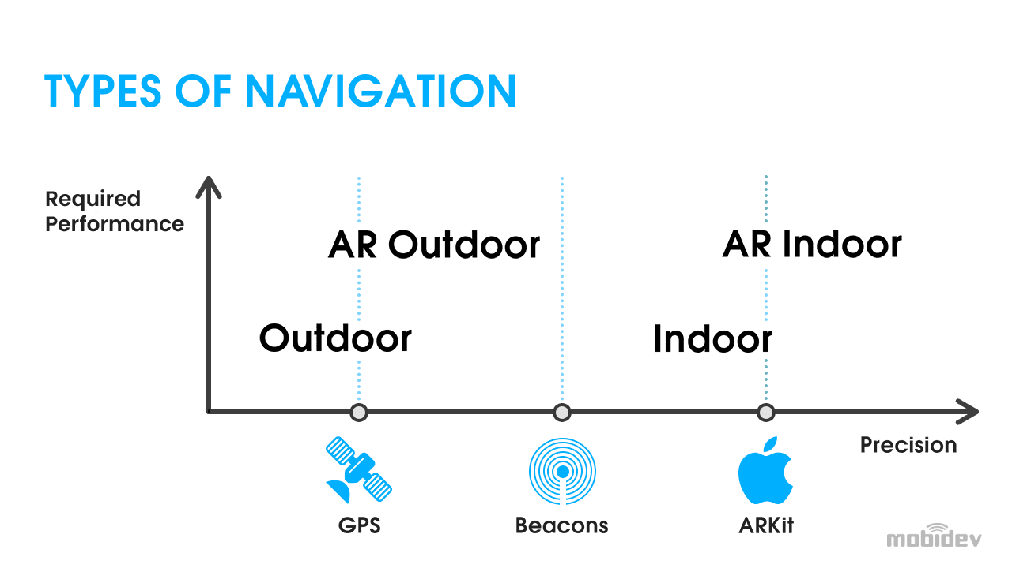

Figure 1 – Different types of navigation[1]

# 3. Market research

In this chapter I will go through the available solutions in the market and similar applications to the one described in this work. There are not many products as the AGH Guide yet, since AR navigation and location based games is relatively a new idea.

## 3.1 Ingress Prime

First released AR location based game to the android market was MMO/Geocaching game from Niantic Inc. called Ingress Prime. It was initially released to Google Play as beta version in 2012 and then it was fully released in 2013 as free-to-play game. It was the predecessor of games like Pokemon GO or The Witcher: Monster Slayer which are well known all around the globe. As Niantic employee Brandon Badger says in the youtube video “Ingress: Design Principles Behind Google's Massively Multiplayer Geo Game”[2] the game’s main goals were to “Get people off the couch”, build local community connections and explore the new augmented reality technologies. As it was one of the first AR location based apps they were pioneers in their field. The game uses mobile device’s GPS system to locate the player and interact with portals that are situated mainly on historical landmarks or monuments. This specific placement of portals encourages people to visit these special places of history and culture. The app presents a map (see figure 2) with completely black background with only marked buildings, roads and bodies of water. These geographical features are provided by OpenStreetMap, which is a free geographical database of the world, and previously they were provided by Google Maps instead. The game’s AR features include only usage of GPS to locate the player and place the xm energy – special energy that allows for different actions in the game – in the real world. More extensions of AR such as projection of objects with the use of camera was added in the later projects of the developers.

Figure 2 – Ingress Prime game view[3]

## 3.2 Pokemon GO

Pokemon GO was one of the biggest mobile games while it was released in 2016. As seen in figure 3, in 2016 its player base reached over 230 millions of active users although it is still quite popular with about 166 million users in the previous year. Pokémon GO as well as other productions like The Witcher: Monster Slayer expanded the augmented reality segments by using the end device’s camera to project virtual models of Pokémons or monsters into the real world. They also added the region and time dependency to the monsters implementing the clock of the phone. Different Pokémons appeared in their specific habitat or at the proper time. The game includes PokéStops and PokéGyms, locations where people can battle each other with their collected and evolved Pokémons. They used Ingress Prime data to populate locations for PokéStops and Gyms in Pokémon GO, that is why they are mainly located on public art or historical landmarks. The fighting mechanics in this game are not sophisticated and based only on Pokémons’ power statistic, it does not incorporate any mechanics.

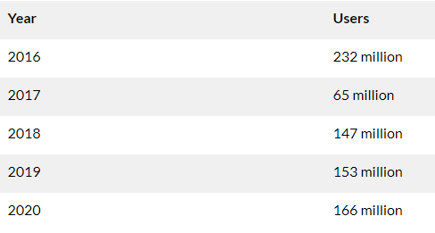

Figure 3 – Pokemon GO active users count[4]

Although there is not much information about the technical specifications and programming used in the Pokemon GO, there is some information about the Ingress Prime and since they are similar games from the same developer it is probable that they used the same tools. Ingress Prime was mainly coded in Java/libgdx, as Anand Akela states in his article “Pokémon Go: A Developer’s Perspective”[5], and he also suspects that they used objective-C/Swift to create the IOS version of the game, which means Pokémon GO incorporates similar languages. Another hint is that Niantic searches for coders with “Key Skills: Unity3D (Unity 3D), C# […]”[5] which means that they are using Unity for their applications and games. Further in the article one can read that the game is integrated with Cloud Bigtable or Cloud Datastore and uses JSON or CSV for data handling and in terms of server interactions relies on RPC interface and Protocol Buffers usage.

# 4. Software environment

In this section I will mention and describe all the environments and programs used to develop the application. Additionally I will compare them to other available solutions and explain why I decided to choose them.

## 4.1 Android: operating system

The app will be implemented on the world’s most used mobile operating system – Android, which is an operating system based on modified linux kernel and other open source software. According to the article from www.phonearena.com, “Google’s Android OS: Past, Present, and Future”[6] it was first released in 2008 on the HTC Dream G1 by company Android Inc. founded in 2003 and acquired by Google in 2005. As figure 4 shows, in the year 2021 approximately 70% of sold mobile devices had Android operating system installed on them, while IOS being second with about 28% of the market share. Since the rest of the operating systems hold insignificant fraction of market share, the comparison will only focus on the first two.

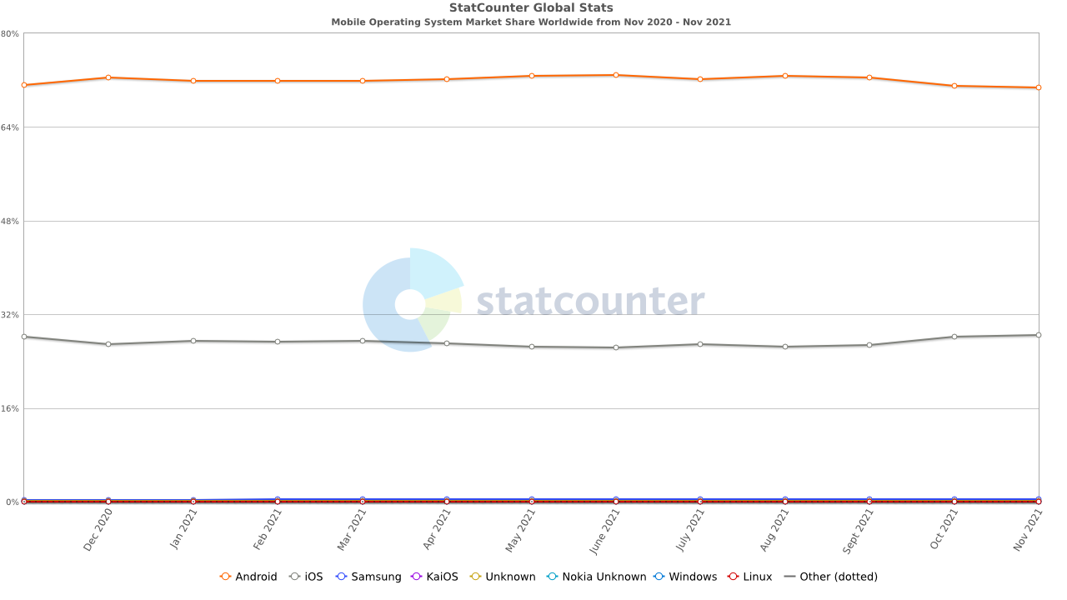

Figure 4 – Mobile operating systems market share[7]

Android and IOS have separate stores for their available applications, Google Play for Android applications and Apple App Store for IOS applications. In terms of number of apps available on each store the Android Google Play is currently in the lead as can be seen on the chart in figure 5, with Apple App Store having about million less apps. Chart in figure 6 points out that more applications are downloaded from Google Play lately in comparison to IOS application store. It specifically shows data from third quarter of 2019 and 2020, where in the latter the difference was over 20 billion of downloaded apps. It also recorded much bigger increase in downloaded applications than Apple App Store in this time period.

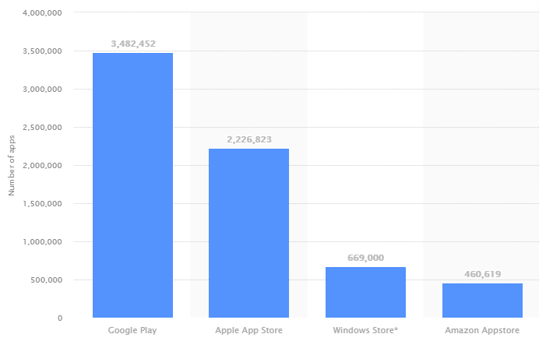

Figure 5 – Number of apps in each app stores[8]

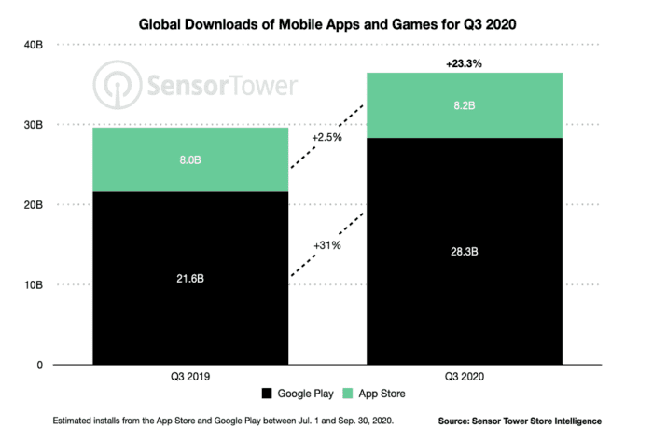

Figure 6 – Apps downloads comparison[9]

According to the data presented above Android is by far the biggest mobile operating system and its application store is growing much faster than that of the second biggest operating system – IOS. This is the reasoning that caused choosing Android as intended operating system for application described in this work and because of that this application will be able to reach the most users.

## 4.2 Unity: game engine

Unity is game engine running on Microsoft Windows, Linux and MacOS operating systems. It is designed to create two or three dimensional games for different platforms like personal computers, game consoles or mobile devices as well as VR and AR applications. As mentioned in the article by Eric Peckham “How Unity built the world’s most popular game engine”[10] Unity was founded in Copenhagen by  Nicholas Francis, Joachim Ante, and David Helgason in 2002. Marie Dealessandri on the other hand in her article “What is the best game engine: is Unity right for you?” says “[…] as of September 2019, 52% of the top 1,000 mobile games were powered by Unity, as well as 60% of all AR/VR content, according to the company. Unity game players are located in 195 countries -- which is literally every single country on the planet”[11]. What makes this game engine so special that most of indie mobile developers use it? Marie Dealessandri explains further in her article that Unity has many advantages like its broad and differential Asset store, its speed and agility, it is easy to learn and free which attracts beginners, and most importantly for this work it is good for VR and AR developers. She also describes its downsides, for example its not suitable for big projects, but they are irrelevant considering application developed and described in this work.

### Programming language

The source code of Unity game engine was mainly written in C++, whereas the game engine allows for writing scripts in UnityScript (similar to JavaScript), C# and Boo. In the AGH Guide application the only programming language used was C# due to its commonness and easy implementation. C# is a general-purpose, [multi-paradigm programming language](https://en.wikipedia.org/wiki/Multi-paradigm_programming_language) that supports many useful programming disciplines like object oriented programming, static typing, strong typing and many more. It was designed by Anders Hejlsberg from Microsoft in 2000 and is approved as international standard by Ecma and ISO according to Microsoft Documentation[12].

### Mapbox SDK

Mapbox SDK for unity is a software development kit created by Mapbox that allows creation of location based games, navigating applications or city simulators in Unity game engine. It offers plenty of already-made solutions for different purposes as well as tools for developing various applications. Amongst its many advantages the most important was the simple method of gathering data from the end device GPS and determining its position in the real world, since Mabbox SDK have prepared script for that. The only difficulty is to correctly implement it into the project. Another useful feature of Mapbox SDK is the ability to render real world map which could be modified and styled freely and it also offers navigation capabilities for driving, walking or cycling. These tools perfectly fit into our needs and simplify the designing process. Additional benefit is the compatibility with AR features and AR navigation which is great for this cause. The other available software development kit that was considered was Google Maps SDK which provides opportunity to utilize Google Maps in Unity, but it was ruled out due to its price. The free trial that Google offered was not sufficient to finish the whole project. Mapbox SDK for Unity offers little less and is free to use which concludes the choice of the SDK.

### ARCore

Another important aspect to consider is the AR implementation tools. The best available tools are the ARKit by Apple and Google’s ARCore. They are open source tools that allow for creation of AR content for mobile devices. The first one is responsible for AR for devices with IOS operating system while the second one is for Android devices, and since the Android operating system has been chosen for this application, the Google AR Core is the only viable option. As Andrew Makarov writes in his article “ARKit vs ARCore: Image Detection and Tracking”[13] surprisingly there are currently more devices with ARKit deployed than with ARCore enabled – as seen in figure 7 in 2020 there are almost twice as many ARKit devices and the users are significantly more active, which is on the contrary to number of IOS and Android powered devices – however “[…] ARCore pulls ahead of ARKit when it comes to mapping. ARCore’s larger mapping dataset increases the speed and quality of mapping that is achieved through the collection and storage of 3D environment information”. This makes the choice of Google’s tool even stronger for this undertaking, although the ARKit is more popular.

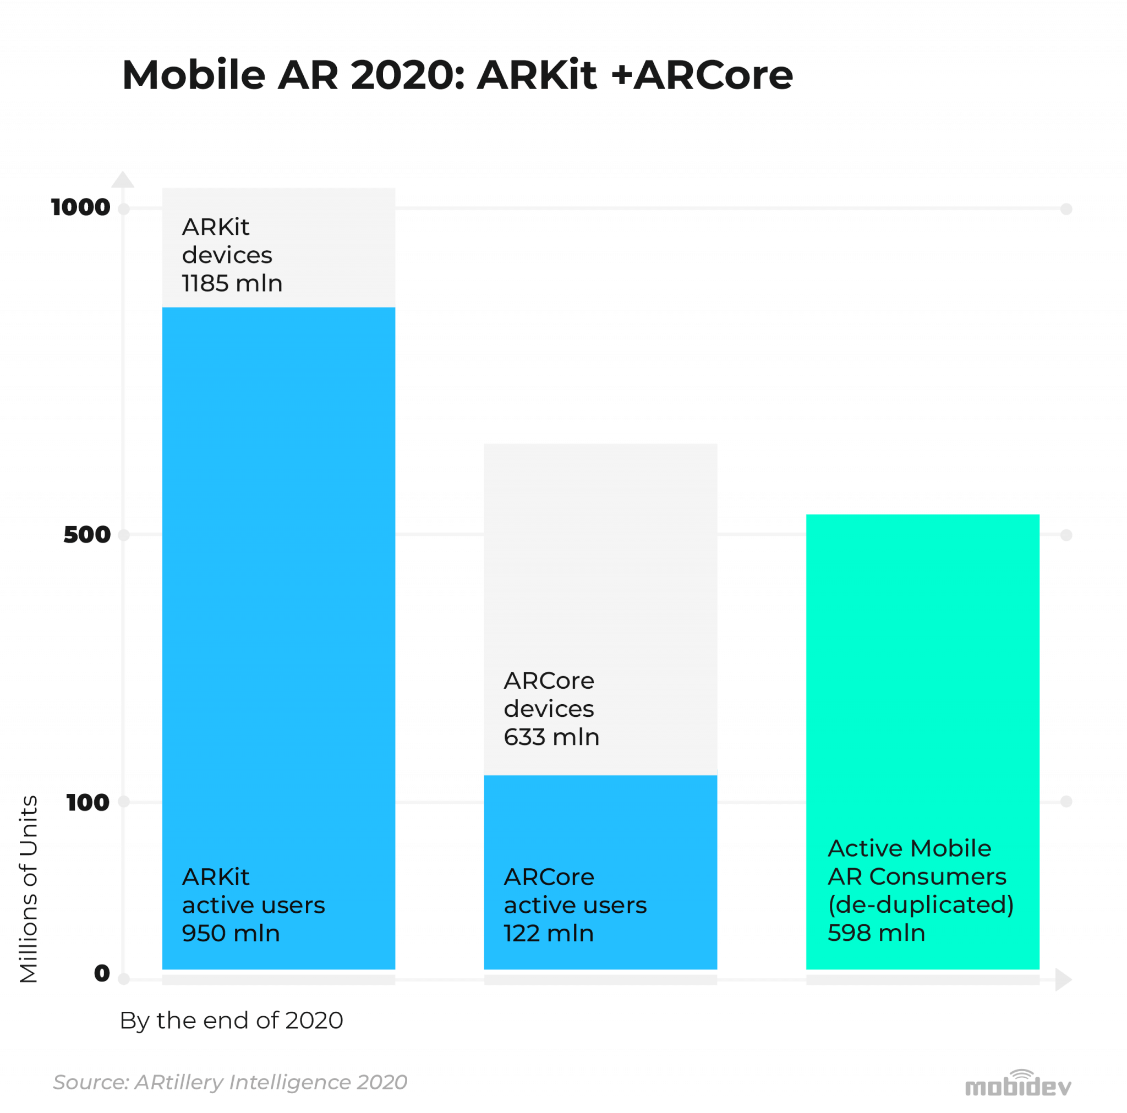

Figure 7 – Comparison of ARKit and ARCore numbers of devices[14]

## 4.3 GIMP: graphics editor

Gimp is a free, open-source graphics editor mainly used for image editing and manipulation. This tool initially created as a semester-long project at University of California, Berkeley by  [Spencer Kimball](https://en.wikipedia.org/wiki/Spencer_Kimball_(computer_programmer)) and [Peter Mattis](https://en.wikipedia.org/wiki/Peter_Mattis) was first released was in 1996. Its main advantages include simple interface, gradient editing, advanced manipulation and animation. It is also simple to use what makes it great for novice application and amateurs, so is perfectly sufficient for this case since it is used to create menu icons and simple graphics.

## 4.4 GitLab: git repository

To store the files and monitor different versions and changes in the application build GitLab web-based git repository was employed. To understand what GitLab is first, one have to be familiar with what is Git – Git is a version control system used in computers to track any changes made in or to the files. It is mainly used to manage various changes in projects of any sizes and it also monitors the whole project - explains Ishan Gaba in his tutorial “What is GitLab and How To use It”[15]. GitLab was developed and released in 2012 by Dimitriy Zaporozhets and Sid Sijbrandij, and is currently owned by GitLab Inc. It was one of the fastest-growing private company in 2018 in America. It is used by many different large and well-known organizations like Sony, NASA or IBM. It provides free, open or private repositories, manages changes made in the repositories and much more. For this project GitLab was used to create backup files, manage changes and monitor the whole application development. It proved incredibly useful to store previous working versions of app with the ability to go back to them if something went wrong. In the figure 8 an exemplary uploaded application build is shown with ready and working navigation segment.

Figure 8 – Project’s GitLab repository

# 5. Developed application

Application description

# 6. Conclusions

Conclusions

# 7. Literature

[1] – Andrew Makarov, *How AR Navigation Works*https://mobidev.biz/blog/augmented-reality-indoor-navigation-app-developement-arkit

[2] – GDC, *Ingress: Design Principles Behind Google's Massively Multiplayer Geo Game.*https://www.youtube.com/watch?v=6otzvQcX_s0

[3] – Figure 2, *Ingress Prime game view.*https://niantic.helpshift.com/a/ingress/?s=getting-started&f=understanding-the-scanner&p=web

[4] – Figure 2, *Pokemon GO active users count.*https://www.businessofapps.com/data/pokemon-go-statistics/

[5] – Anand Akela, *Pokémon Go: A Developer’s Perspective.*  
https://www.appdynamics.com/blog/product/pokemon-go-a-developers-perspective/

[6] – FAUguy, *Google’s Android OS: Past, Present and Future.*https://www.phonearena.com/news/Googles-Android-OS-Past-Present-and-Future_id21273

[7] – Figure 3, *Mobile operating systems market share.*https://gs.statcounter.com/os-market-share/mobile/worldwide

[8] – Figure 4, *Number of apps in each app stores.*  
https://www.statista.com/statistics/276623/number-of-apps-available-in-leading-app-stores/

[9] – Figure 5, *Apps downloads comparison.*  
https://buildfire.com/app-statistics/

[10] – Eric Peckham, *How Unity built the world’s most popular game engine.*https://techcrunch.com/2019/10/17/how-unity-built-the-worlds-most-popular-game-engine/

[11] – Marie Dealessandri, *What is the best game engine: is Unity the right engine for you?*https://www.gamesindustry.biz/articles/2020-01-16-what-is-the-best-game-engine-is-unity-the-right-game-engine-for-you

[12] – *Micorosft C# Documenation.*  
https://docs.microsoft.com/pl-pl/dotnet/csharp/language-reference/language-specification/introduction

[13] – Andrew Makarov, *ARKit vs ARCore: Image Detection and Tracking.*https://arpost.co/2020/06/12/arkit-vs-arcore-image-detection-and-tracking/

[14] – Figure 6, *Comparison of ARKit and ARCore numbers of devices.*https://mobidev.biz/blog/augmented-reality-future-trends-2018-2020

[15] – Ishan Gaba, *What is GitLab and How To use It?*https://www.simplilearn.com/tutorials/git-tutorial/what-is-gitlab